Lab Experiments

NAME: N. Hima Harshitha
REG NO: 192371063
COURSE NAME: Internet Programming
COURSE CODE: CSA4308

Experiment 1:
Code:
<!DOCTYPE html>
<html>
<head><title>Library</title></head>
<body>
<h2>Library Management</h2>

<input type="text" placeholder="Search Book"><br><br>
<button>Search</button>
<button>Login</button>
<button>Register</button>

<h3>Books</h3>
<ul>
<li>Java Programming</li>
<li>Python Basics</li>
<li>Web Development</li>
</ul>

<a href="#">Borrow History</a><br>
<a href="#">Check Fine</a><br>
<a href="#">Download Material</a>

</body>
</html>

Output:
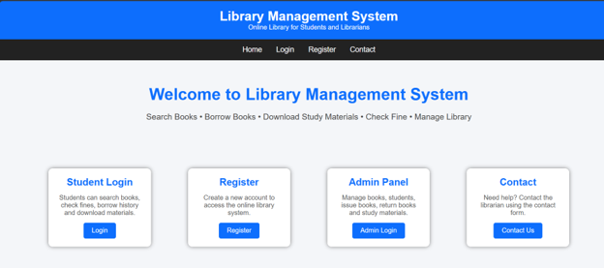

Experiment 2:
Code:
<!DOCTYPE html>

<html>
<head>
<title>Hotel Booking</title>
<style>
body{text-align:center;font-family:Arial}
.box{background:#eee;padding:20px;margin:30px}
input,button,select{padding:10px;margin:5px}
</style>
</head>

<body>

<div class="box">

<h1>Online Hotel Booking</h1>

<input placeholder="Customer Name">
<input placeholder="Destination">

<select>
<option>Single Room</option>
<option>Double Room</option>
<option>Luxury Room</option>
</select>

<input type="date">

<button onclick="book()">Book Room</button>

<h3>Booking Details</h3>
<p id="result"></p>

<h3>Admin</h3>
<button>Add Room</button>
<button>Change Price</button>
<button>Cancel Booking</button>

</div>

<script>
function book(){
result.innerHTML="Room booked successfully";
}
</script>

</body>
</html>

Output:
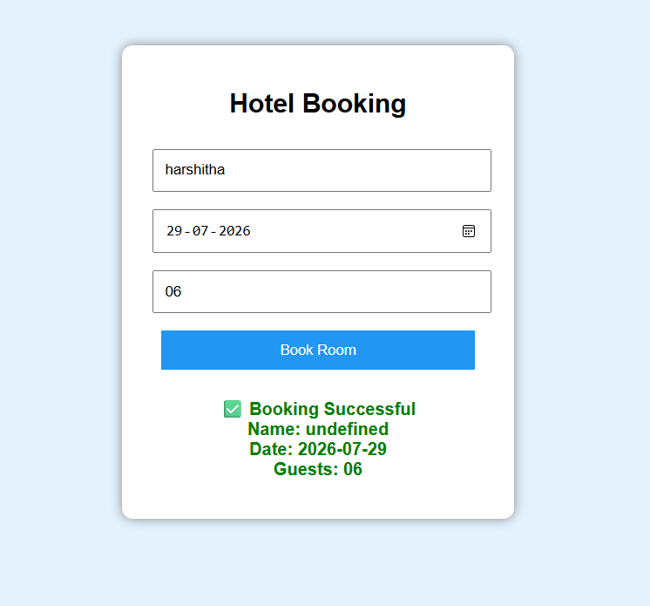
Experiment 3:
Code:
<!DOCTYPE html>
<head>
<title>Bus Reservation</title>
<style>
body{text-align:center;font-family:Arial}
.box{background:#eee;padding:20px;margin:20px}
input,button,select{padding:8px;margin:5px}
</style>
</head>

<body>

<div class="box">

<h1>Bus Ticket Booking</h1>

<input placeholder="From">
<input placeholder="To">

<input type="date">

<select>
<option>Volvo</option>
<option>Sleeper</option>
<option>AC Bus</option>
</select>

<button onclick="ticket()">Book Ticket</button>

<h3>Admin Panel</h3>

<button>Add Bus</button>
<button>Update Bus</button>
<button>Generate Report</button>

<p id="msg"></p>

</div>

<script>
function ticket(){
msg.innerHTML="Ticket booked successfully";
}
</script>

</body>
</html>

Output: 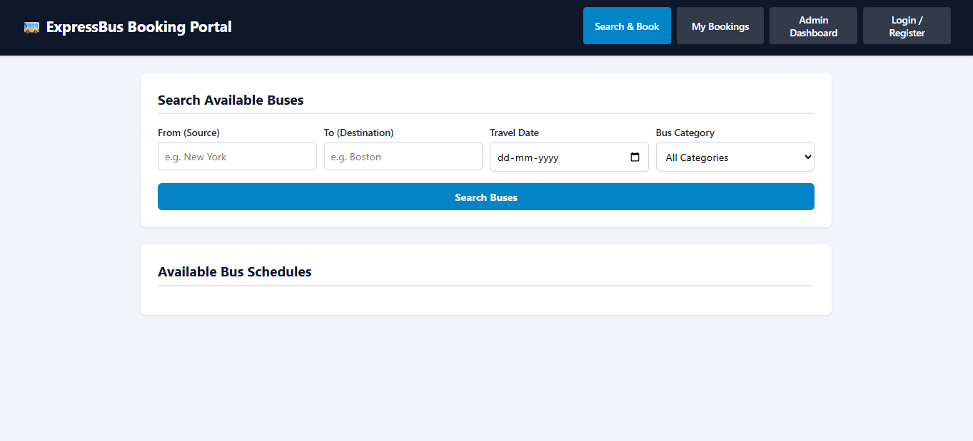

Experiment 4:
Code:
<!DOCTYPE html>
<html>
<head>
<title>Train Reservation</title>
<style>
body{text-align:center;font-family:Arial}
div{background:#eee;padding:20px;margin:20px}
input,button,select{padding:8px;margin:5px}
</style>
</head>

<body>

<div>

<h1>Train Reservation System</h1>

<input placeholder="Source">
<input placeholder="Destination">

<input type="date">

<select>
<option>AC</option>
<option>Sleeper</option>
<option>General</option>
</select>

<button onclick="reserve()">Reserve Ticket</button>

<h3>PNR Status</h3>

<input placeholder="PNR Number">
<button>Check</button>

<h3>Admin</h3>
<button>Add Train</button>
<button>Update Fare</button>

<p id="out"></p>

</div>

<script>
function reserve(){
out.innerHTML="Ticket Confirmed";
}
</script>

</body>
</html>

Output:
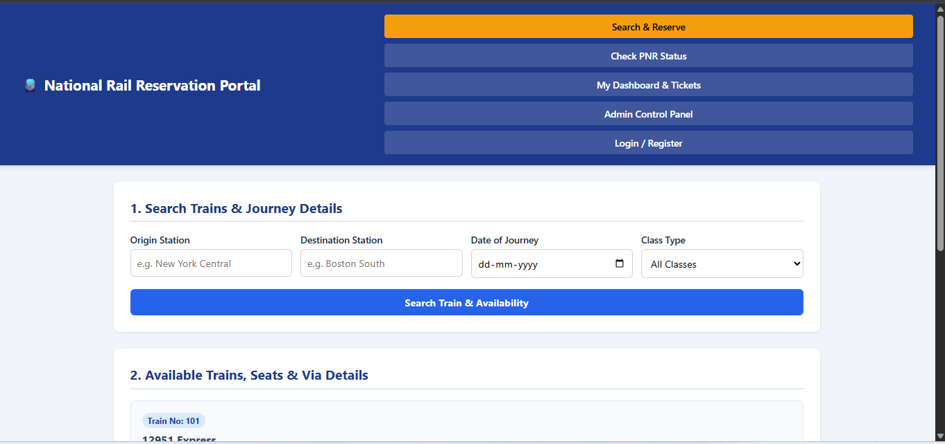

Experiment 5:
Code:
<!DOCTYPE html>
<html>
<head>
<title>Flight Reservation</title>

<style>
body{text-align:center;font-family:Arial}
.box{background:#eee;padding:20px;margin:20px}
input,button,select{padding:8px;margin:5px}
</style>

</head>

<body>

<div class="box">

<h1>Flight Reservation System</h1>

<input placeholder="Departure">
<input placeholder="Arrival">

<input type="date">

<select>
<option>Economy</option>
<option>Business</option>
</select>

<button onclick="flight()">Book Flight</button>

<h3>User</h3>
<button>My Ticket</button>
<button>Cancel Ticket</button>
<button>Print Ticket</button>

<h3>Admin</h3>
<button>Add Flight</button>
<button>Manage Seats</button>

<p id="demo"></p>

</div>

<script>
function flight(){
demo.innerHTML="Flight Ticket Confirmed";
}
</script>

</body>
</html><li>First Class</li>
</ul>

<a href="#">My Tickets</a>

</body>
</html>

Output:
